Assignment 3

**Question 1**

1. **What** are business processes? **How** are they related to information systems?

Business processes are the collection of activities required to produce a product or service. These activities are supported by flows of material, information, and knowledge among the participants in business processes. Business processes also refer to the unique ways in which organi- zations coordinate work, information, and knowledge, and the ways in which management chooses to coordinate work.

A business process is a logically related set of activities that defines how specific business tasks are

performed, and it represents a unique way in which an organization coordinates work, information, and knowledge. Managers need to pay attention to business processes because they determine how well the organization can execute its business, and they may be a source of strategic advantage. There are business processes specific to each of the major business functions, but many business processes are cross-functional. Information systems automate parts of business processes, and they can help organizations redesign and streamline these processes.

Every business can be seen as a collection of business processes, some of which are part of larger encompassing processes. For instance, uses of mentoring, wikis, blogs, and videos are all part of the overall knowledge management process. Many business processes are tied to a specific functional area. For example, the sales and marketing function is responsible for identifying customers, and the human resources function is responsible for hiring employees.

**Business processes** refer to the set of logically related tasks and behaviors that organizations develop over time to produce specific business results and the unique manner in which these activities are organized and coordinated. Developing a new product, generating and fulfilling an order, creating a marketing plan, and hiring an employee are examples of business processes, and the ways organizations accomplish their business processes can be a source of competitive strength.

**HOW INFORMATION TECHNOLOGY IMPROVES BUSINESS PROCESSES**

Exactly how do information systems improve business processes? Information systems automate many steps in business processes that were formerly performed manually, such as checking a client’s credit, or generating an invoice and shipping order. But today, information technology can do much more. New technology can actually change the flow of information, making it possible for many more people to access and share information, replacing sequential steps with tasks that can be performed simultaneously, and eliminating delays in decision making. New information technology frequently changes the way a business works and supports entirely new business models. Downloading a Kindle e-book from Amazon, buying a computer online at Best Buy, and down- loading a music track from iTunes are entirely new business processes based on new business models that would be inconceivable without today’s information technology. Information technology improves business processes by automating manual tasks, changing the flow of information, enabling simultaneous task execution, and eliminating delays in decision-making. The automation of steps such as credit checks or invoice generation enhances efficiency, while new technologies reshape how businesses operate and introduce entirely new business models. Understanding and analyzing business processes is crucial in information systems courses and future careers, as it provides insights into how a business works and how to leverage information technology for greater efficiency, innovation, and customer service

1. **How** do systems serve the different management groups in a business? **What** is the role of the information systems function in a business?

Systems serving operational management are transaction processing systems (TPS), such as payroll or order processing, that track the flow of the daily routine transactions necessary to conduct business. Management information systems (MIS) produce reports serving middle management by condensing information from TPS, and these are not highly analytical. Decision-support systems (DSS) support management decisions that are unique and rapidly changing using advanced analytical models. All of these types of systems provide business intelligence that helps managers and enterprise employees make more informed decisions. These systems for business intelligence serve multiple levels of management, and include executive support systems (ESS) for senior management that provide data in the form of graphs, charts, and dashboards delivered via portals using many sources of internal and external information.

A business firm has systems to support different groups or levels of management. These systems include transaction processing systems and systems for business intelligence.

**Transaction Processing Systems**

Operational managers need systems that keep track of the elementary activities and transactions of the organization, such as sales, receipts, cash deposits, payroll, credit decisions, and the flow of materials in a factory. **Transaction processing systems (TPS)** provide this kind of information. A transaction processing system is a computerized system that performs and records the daily routine transactions necessary to conduct business, such as sales order entry, hotel reservations, payroll, employee record keeping, and shipping. The principal purpose of systems at this level is to answer routine questions and to track the flow of transactions through the organization.

Transaction processing systems are often so central to a business that TPS failure for a few hours can lead to a firm’s demise and perhaps that of other firms linked to it. The Interactive Session on Technology describes the impact on airline travel when automated baggage handling systems are not working properly.

Management Information Systems (MIS) focus on summarizing past transactional data, providing structured reports for middle-level managers. Decision Support Systems (DSS) offer flexible tools for ad-hoc decision-making, aiding analysis and scenario assessment. Executive Support Systems (ESS) cater to strategic decision-making at the executive level, presenting highly summarized information for a broader strategic perspective.

Im

**Importance of Information Systems for Businesses**

The information systems department is the formal organizational unit responsible for information technology services. It is responsible for maintaining the hardware, software, data storage, and networks that comprise the firm’s IT infrastructure. The department consists of specialists, such as programmers, systems analysts, project leaders, and information systems managers, and is often headed by a CIO.

The information systems function in a business is managed by the information systems department, responsible for maintaining the hardware, software, data storage, and networks constituting the firm's IT infrastructure. This department includes specialists like programmers, systems analysts, project leaders, and information systems managers. The CIO, often heading the department, oversees the strategic use of information technology, while positions like CSO, CKO, and CPO contribute to security, knowledge management, and privacy.

End users, representing various departments, actively participate in designing and developing information systems. The information systems department has evolved to include more systems analysts and network specialists, serving as a change agent by suggesting new business strategies.

The organization and governance of the information systems function vary among different types of firms. IT governance, which includes strategy and policies, decision rights, and accountability frameworks, plays a crucial role in ensuring that IT supports the organization's strategies effectively. Superior IT governance provides well-thought-out answers to questions about centralization, decision-making processes, and effective management of IT investments.

**Question 2**

1. **Draw** a neat diagram of Information requirements of key decision-making groups in a firm.

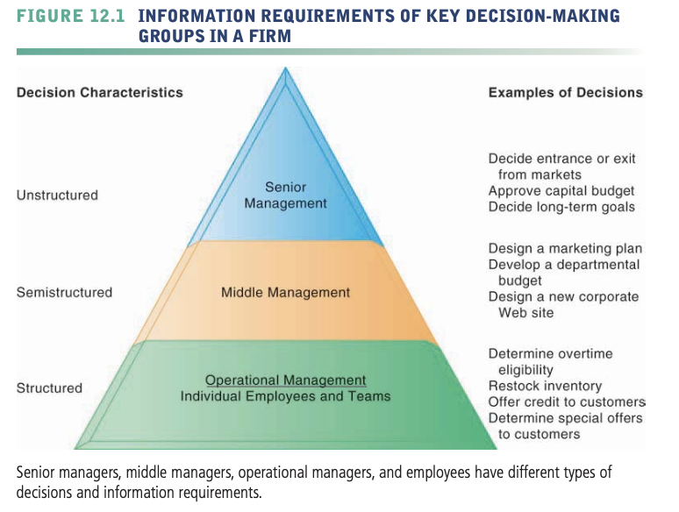

Unstructured decisions require judgment and insight, are novel and nonroutine, and lack predefined procedures. Structured decisions are routine and repetitive, following specific procedures. Semi-structured decisions involve a mix of both types. Unstructured decisions are common at higher organizational levels, while structured decisions prevail at lower levels. Senior executives face unstructured decisions like setting long-term goals, whereas middle management deals with semi-structured scenarios. Operational management and rank-and-file employees typically handle more structured decisions, such as overtime approval or credit extension based on preset criteria.

1. **Draw** a neat diagram of Business intelligence and analytics for decision support

Managers play a crucial role in utilizing business intelligence (BI) tools, applying managerial methods to analyze data, set strategic goals, and measure progress. Business performance management and balanced scorecard approaches are employed, focusing on key performance indicators and industry strategic analyses. Senior management oversight is essential to ensure BI produces relevant information. Results from BI are delivered through Management Information Systems (MIS), Decision Support Systems (DSS), and Executive Support Systems (ESS) to operational employees, middle managers, and senior executives. Modern BI emphasizes visual representations like dashboards and scorecards, allowing access via desktops, mobile platforms, and social media for effective decision-making.